THE FRAME
  - HABITAT FOR HUMANITY
  - OF CENTRAL IOWA AUGUST 2020
To our faithful partners,

We thought it was necessary to update you all on what is going on here in Ames. As the global effect of COVID-19 continues to evolve, Habitat for Humanity of Central Iowa is firmly committed to the health and safety of our partners, employees, volunteers, and our community. Daily we monitor and evaluate the ever-changing situation, and work to comply with the public health guidance.
Putting safety as a top priority, we have increased our protocols on sanitizing surfaces, face masks are required to shop in our store, and social distancing is mandated both in the store and our office. The safety of all remains our number one priority.
We have adjusted our store hours to Tuesday-Saturday, 10-4 pm. As always, we are looking for volunteers to help work in our store during those times. You can be assured that your safety is very important to us and we will take the time to provide you with adequate training in the area you feel qualified to help. If you are interested, please call 515-232-8815 and ask for Betty, our office coordinator.
Though COVID-19 has stolen so much time from us, it has not taken away our mission and motivations. Our house on Morningside, the 60th home HFHCI has worked on, will be completed at the end of the month. We are ecstatic for our partner family to move in. Donating over 400 hours of sweat equity, our family has put hammer to nail, making this home very special.
As a non-profit organization, we survive on the generosity of partners like you. Whether that is a financial donation, supply donation to our store, our through shopping locally with us, your generosity is so valued. Thank you for your continued support and trust as we work to provide affordable housing here in Central Iowa.

“Everybody brings different skills and abilities, and we need them all.” -Habitat volunteer Ron Konkol

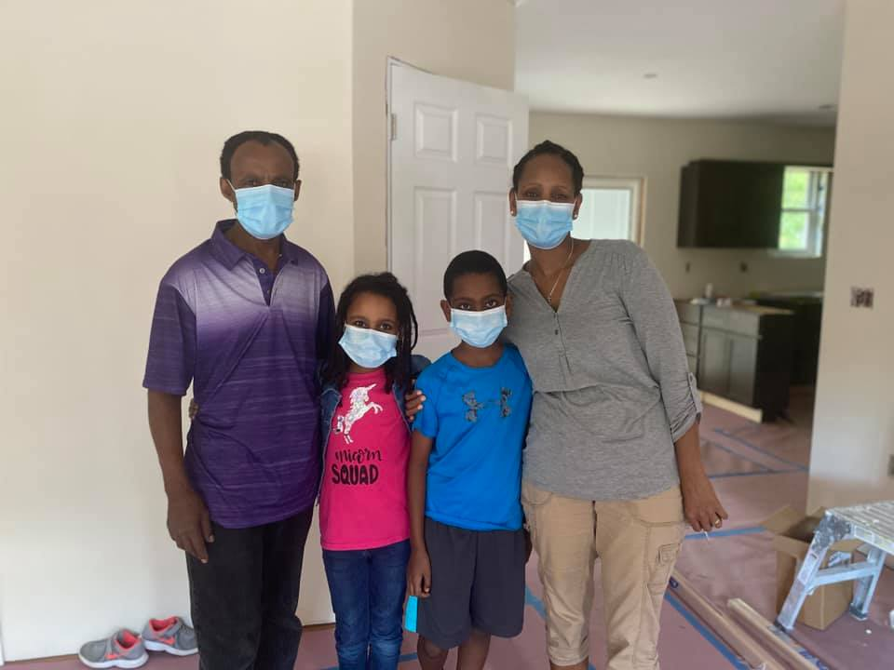  Our partner family is excited for their home dedication on  Septermber 4th, 2020  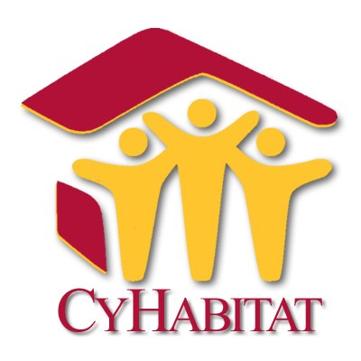  We are so excited to welcome back the ISU students who play such an importaint role  for us. Welcome back the Beta Psigma Psi Fraternity and CyHabitat Club. We are blessed by  your hard work.  www.hfhci.org | 515-232-8815 | outrech@hfhci.org |  | “Our volunteer staff, while diminished in numbers due to the COVID-19 threat, has been outstanding in stepping up to be sure we have enough help every day”. –Dan T., Store Manager
website | phone number | email

