Seasonings Greetings to Our Habitat Friends:
As 2021 comes to an end I would like to take this opportunity to thank you for your support. It enabled us to have a successful year and help our Habitat families. Here is a bit of information about them.
Daniel Gheresus and his family are one of 68 families who own a home built by your local Habitat for Humanity of Central Iowa. Each home built by our affiliate is a collaborative, community effort. Habitat homes are built with funds donated from our local community and through the generosity of our valuable volunteers each year. Daniel and his wife Senaite Tekke recently moved into their Habitat home during Covid. What a hard time for building and change for everyone. They are so happy to be celebrating the holidays as a blessed family in their new home.
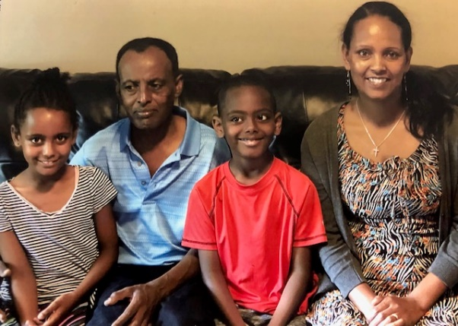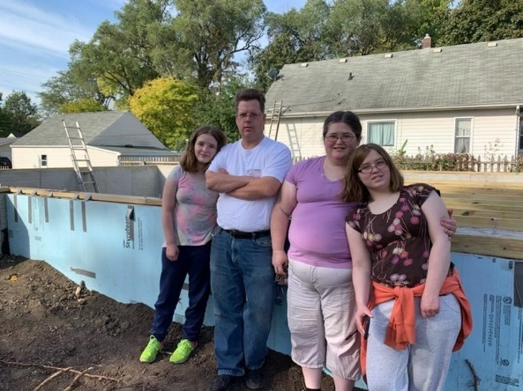
Daniel Gheresus Family Donald Hendrian Family
The Hendrian family is in the process of becoming homeowners. Their home will be located on 10th Street here in Ames. Donald, his wife, and three children are busy working on their sweat equity hours and preparing to move from their mobile home to a new home. Like the Gheresus family, the Hendrians are looking forward to brightening their future. They will complete 400 hours of sweat equity and attend HUD approved homeownership classes. When they turn the key on their new home they will make monthly mortgage payments on a 0% interest mortgage. Their payment includes taxes and homeowner’s insurance. We are also in the process of a new build located on Grand Avenue in Ames. This build is a partnership with the City of Ames. The Kinert family has recently been selected for the Grand Avenue build. We look forward to working with them in the coming year.
Owning a well-built, energy efficient home provides stability and allows families to launch themselves into a cycle of progress, possibility, and a better quality of life. Homeownership rekindles hope and allows families and our community to thrive. There are many hard-working families that qualify for Habitat’s program in our community. We need your help to serve them.
No gift is too big or too small. Every dollar is needed to help our hardworking families realize their dream of homeownership. Please help us by donating today. Thank you from all of us at Habitat.
Merry Christmas!
Most Sincerely,
Sandi Risdal
Executive Director
Habitat for Humanity of Central Iowa

