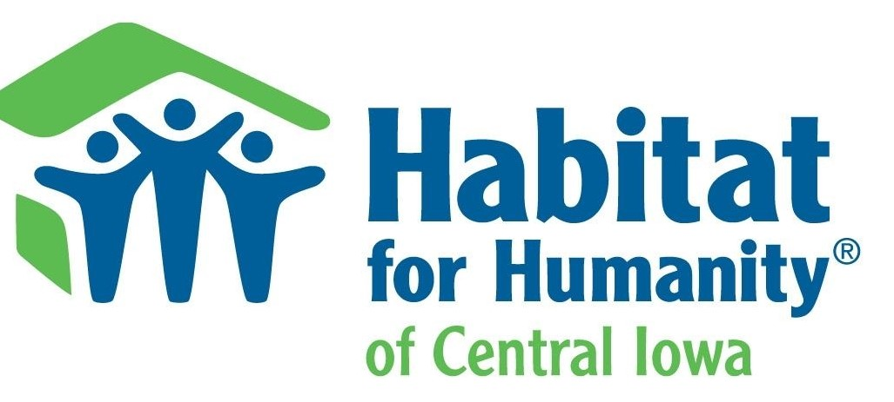 3504 Grand Avenue ~ Ames, IA. 50010
  - Spring 2022
A success Story
Habitat for Humanity of Central Iowa will be completing our 68th home build this year. The home, at 12th Street and Grand Avenue in Ames, is a monumental accomplishment.
Please help us continue Sandi’s legacy by contributing to our building fund for her final project as Executive Director.
We don’t just build homes,
We build communities!

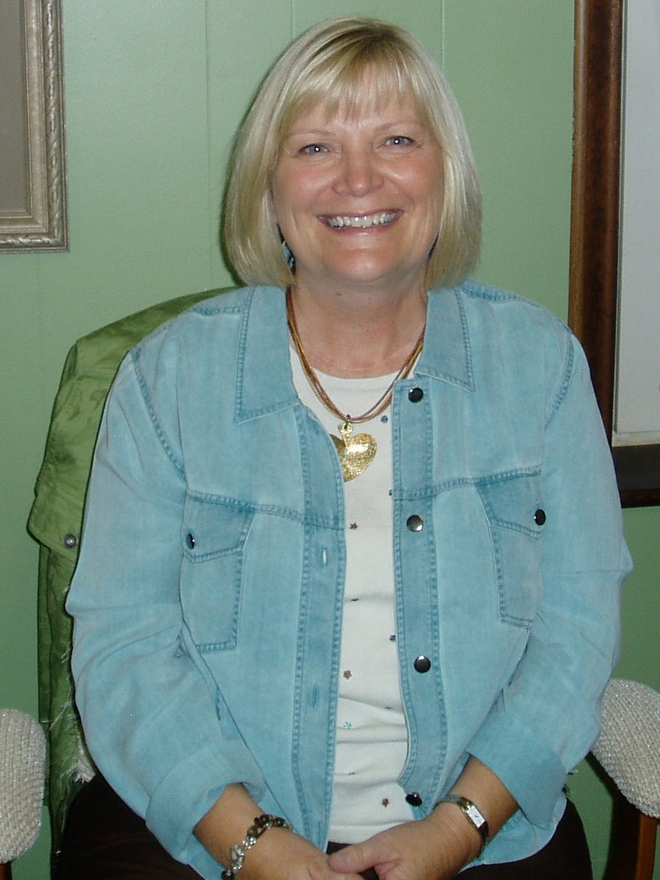
Sandi Risdal

Retirement
As most of you know by now, Sandi Risdal is retiring this April after serving as the Executive Director of Habitat for Humanity of Central Iowa for 15 years.

Our appreciation for all that Sandi has accomplished during her 15 years tenure is immeasurable!
She has been instrumental in the growth of our organization, from a little office tucked away in downtown Ames to the big beautiful building we now enjoy on Grand Avenue in Ames. Our growth from garage and parking lot sales to our first real “store” on East Lincoln Way, to our fabulous Store location on Grand Avenue we inhabit today has been unprecedented.

Sandi has been the inspiration and driving force behind all this growth and Community involvement.
She has built a Team of hard working and loyal staff and volunteers who are dedicated to her vision and the mission of HFHCI. Her joy and compassion are infectious and motivate us all to try and do better.

Even on the “bad” days, Sandi has always been a joy to work with and an inspirational leader.
The many families HFHCI has helped are all very near and dear to Sandi’s heart.

Sandi says, “Another joy and bonus of my position has been working with our families … I have truly loved every minute. Getting to know them, watching them work on and build their home has been such an inspiration.”
No question, Sandi Risdal will be greatly missed. It will not be easy for anyone to fill her shoes. However, Sandi’s legacy of accomplishments will live on for many years to come. Thank You!

So Much new and exciting!
Under Sandi’s leadership we have so much new and exciting “stuff” going on. We have our wonderful new Store and Office location on Grand Avenue in Ames. We have recently purchased a 2nd delivery truck to keep up with the demands of our Store sales. We’re adding more staff to our Store delivery Team to meet the demand.
We’ll be getting our new truck wrapped in an eye catching design this spring to serve as a mobile billboard for HFHCI.
We now have an Online Store to complement our bricks & mortar Store. The Online Store is easily accessable via our HFHCI website, simply click on the “SHOP” tab at the top of the home page. Our Online Store has only been open for a few weeks and sales are already brisk.
We’re doing even more to further raise our visibility within the Community. From having a booth at this summer’s Donwtown Ames Farmer’s Market to Radio Ads to making numerous presentations to civic and faithbased groups.

But wait, there’s more …
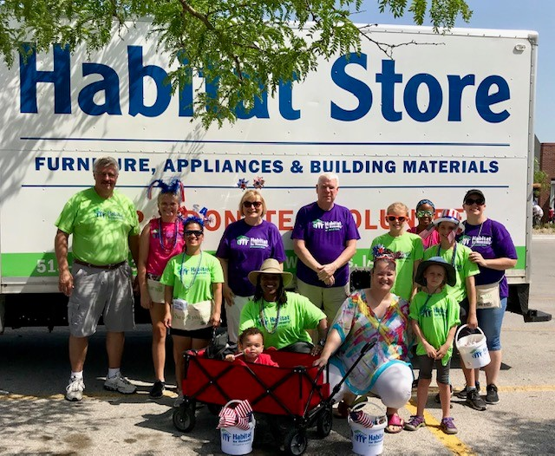
You’ve come a long way!
Our growth has been amazing!
Everything HFHCI has been able to accomplish in the past 15 years is truly remarkable.

It’s hard to believe just how far we’ve come. It’s been one heck of a ride! And, we’re not done yet.

Our growth has been phenomenal these past 15 years. So many changes, so many improvements.

The contributions to our Community have been immense. The many families who have been helped and the public awareness of the need for more decent and affordable housing.

Now, more than ever we need your support!
One of the keys to our continued success is the success of our Habitat Store. Store sales are crucial to our growth and fund in large part our current and future home builds.

Donate, Shop, Volunteer
We need your donations of gently used furniture, appliances, home décor, tools, building materials and more.
We need you to support our Store and shop local.
We need you to Volunteer. In the Store, on a Build, or even in the Office.
We have a lot of new and exciting things in the works for the months and years ahead, as we follow through on Sandi’s vision for HFHCI.
Sandi and our entire Team of staff and volunteers take great pride in what we have built. With a clear vision for the future and new goals set, we are all looking forward to what’s ahead for Habitat for Humanity of Central Iowa.
Recipient Name
Street Address
City, ST ZIP Code

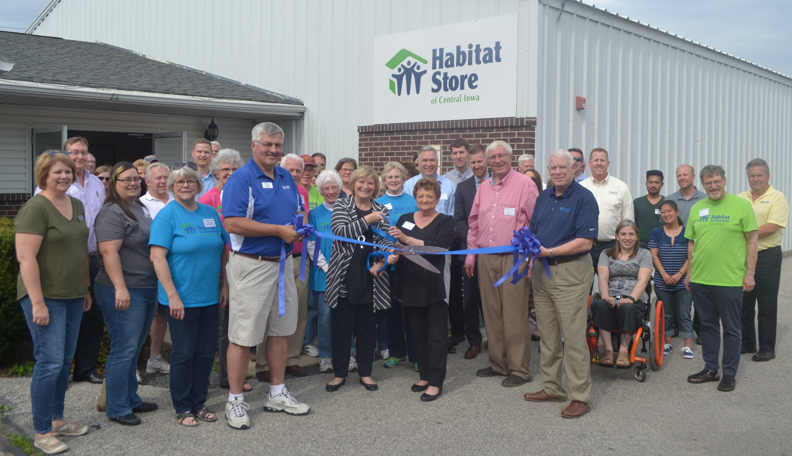

We appreciate all the wonderful support the Community has given us over the years!
Thank you for all you’ve done for us which has made it possible for us to do so much for our Community. Looking forward to another 15 great years!
Tom Lockhart ~ Marketing/Community Development

